**Project Design Phase-II**

**Technology Stack (Architecture & Stack)**

|  |  |
| --- | --- |
| Date | 21 October 2022 |
| Team ID | PNT2022TMID37704 |
| Project Name | Project – Inventory Management System for Retail Store |
| Maximum Marks | 4 Marks |

**Technical Architecture:**

The Deliverable shall include the architectural diagram as below and the information as per the table1 & table 2

**Order processing during pandemics for offline mode**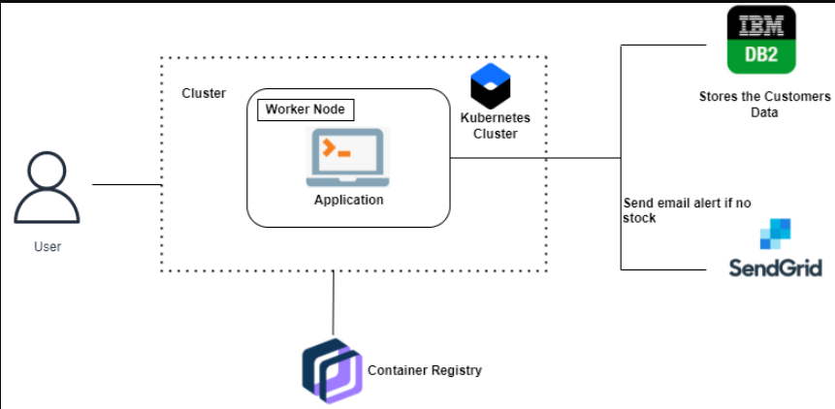

**Table-1 : Components & Technologies:**

|  |  |  |  |
| --- | --- | --- | --- |
| **S.No** | **Component** | **Description** | **Technology** |
|  | User Interface | How user interacts with application e.g.  Web UI, Mobile App, Chatbot etc. | HTML, CSS, JavaScript, Pyhton |
|  | Application Logic-1 | Logic for a process in the application | IBM Watson STT service |
|  | Application Logic-2 | Logic for a process in the application | IBM Watson Assistant |
|  | Database | Data Type, Configurations etc. | MySQL. |
|  | Cloud Database | Database Service on Cloud | IBM DB2, IBM Cloudant etc. |
|  | File Storage | File storage requirements | IBM Block Storage or Other Storage Service or Local Filesystem |
|  | External API-1 | Purpose of External API used in the application | SendGrid |
|  | Infrastructure (Server / Cloud) | Application Deployment on Local System / Cloud | Kubernetes, Docker, IBM cloud |

**Table-2: Application Characteristics:**

| **S.No** | **Characteristics** | **Description** | **Technology** |
| --- | --- | --- | --- |
|  | Open-Source Frameworks | Flask is used for interaction and connection with application | Python Flask |
|  | Scalable Architecture | Presenting tier: User interface for login and updating stocks. | HMTL, CSS, Flask, IBM DB2 |
|  | Availability | Availability can be made by using cloud. | Kubernetes, Docker |
|  | Performance | Performance of the application can be improved by adding the containers in cloud DB | Kubernetes, Docker |